**PROGRAM GAJI LEMBUR**

**Program**

1. **Program**

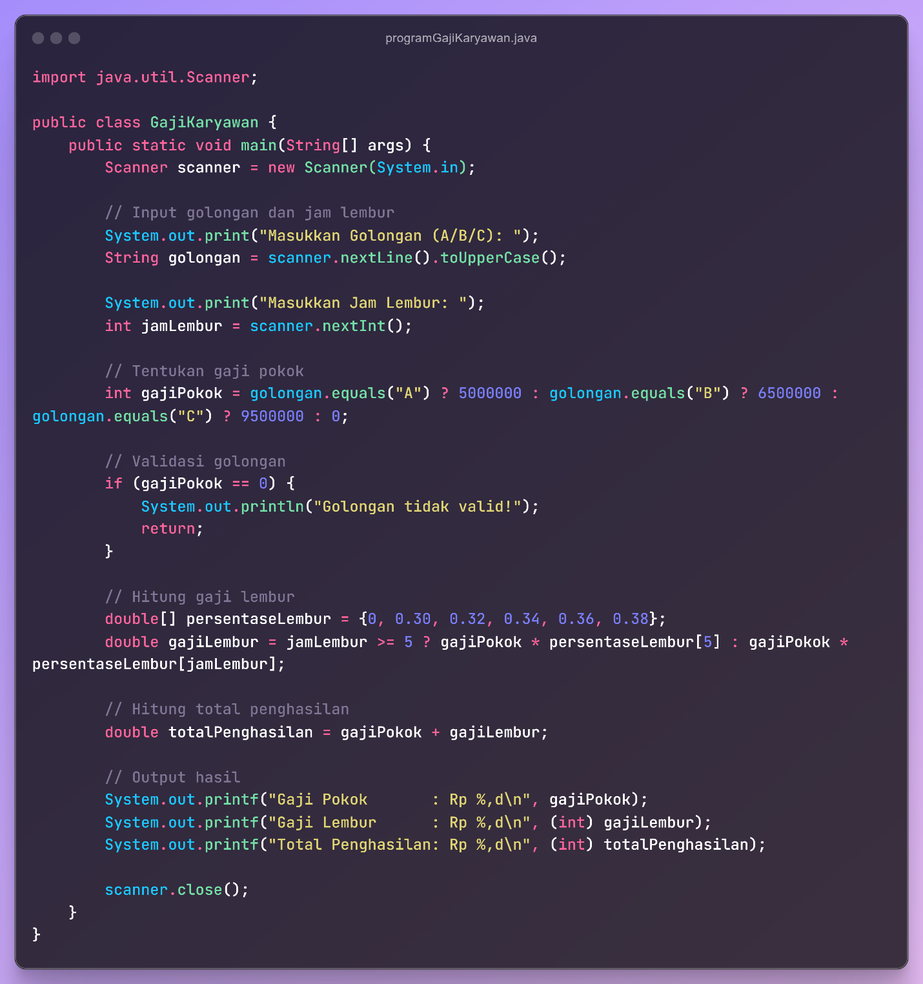

[raw.githubusercontent.com/mabica-creative/Tugas/refs/heads/main/PROGRAM GAJI LEMBUR/program.java](https://raw.githubusercontent.com/mabica-creative/Tugas/refs/heads/main/PROGRAM%20GAJI%20LEMBUR/program.java)

1. **Terminal**

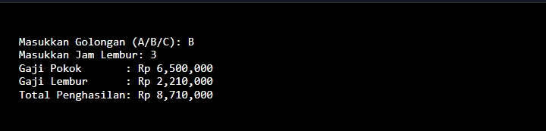

1. **Video**